Cairo University Faculty of Computers and Artificial Intelligence



**Software design specification document**

**2022**

**Project Team**

|  |  |  |
| --- | --- | --- |
| **ID** | **Name** | **Email** |
| 20200155 | Hassan Ali Mohamed | [Sonson2015.android@gmai.com](mailto:Sonson2015.android@gmai.com) |
| 20200344 | Omar Salama Mostafa | [Osalama216@gmail.com](mailto:Osalama216@gmail.com) |
| 20200431 | Mohamed Ayman Ibrahim | [Ayman25mohammad@gmail.com](mailto:Ayman25mohammad@gmail.com) |
| 20200437 | Mohamed Gamal Ragab | [Mohamed6688745@gmail.com](mailto:Mohamed6688745@gmail.com) |

Contents

Class diagram design 2

Class diagram Explanation 3

Sequence diagram design 3

Github repository link 4

# Class diagram design

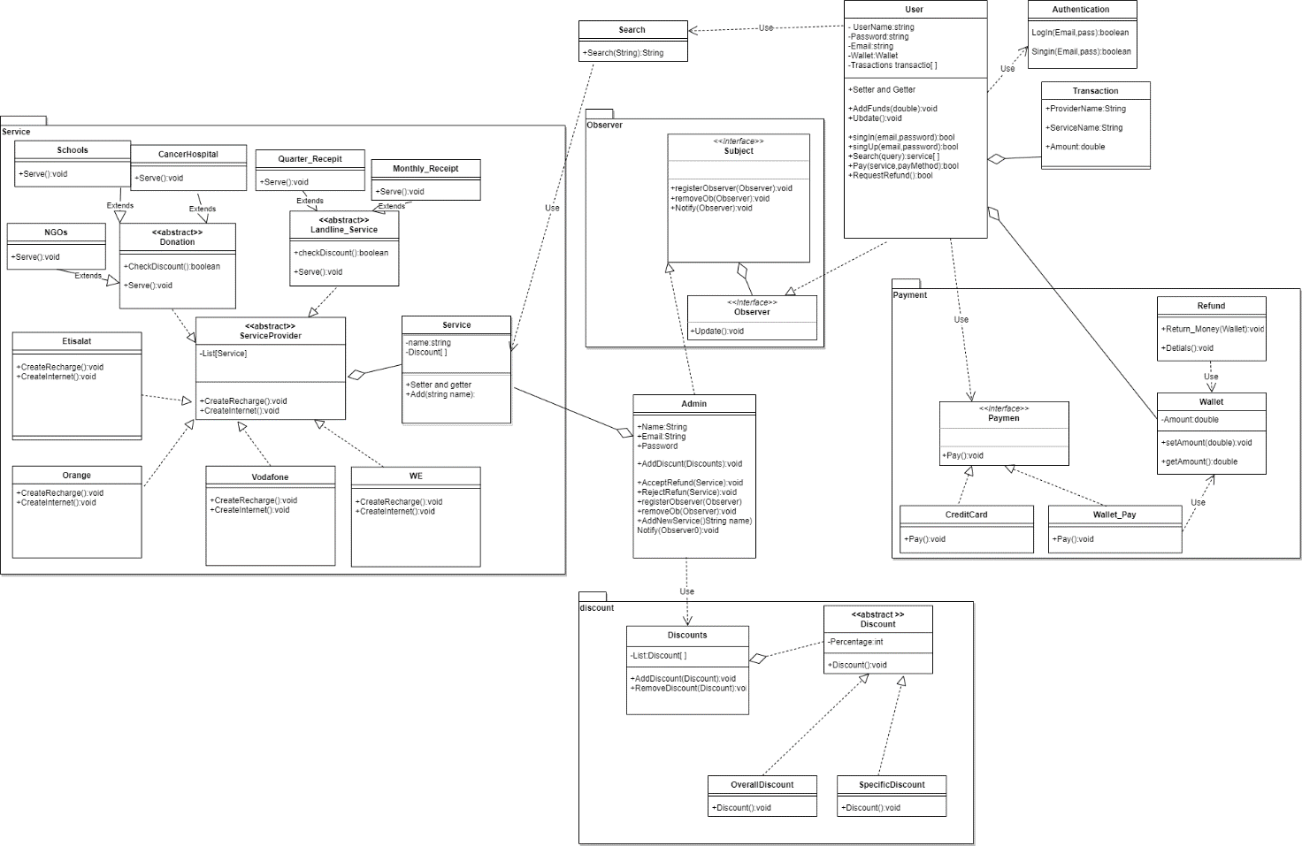

# Class diagram Explanation

1. Factory Method: we use this pattern in Service Provider, to make it easy to create any type of service provider ,like (WE, Orange,Etisalat,..etc)
2. Observer Pattern: we use this Pattern to make admin notify any user that its refund request accepted or not .
3. Strategy: we use this in many places like Discount to determine what type of discount the admin are going to apply to the Service.

# Sequence diagram design

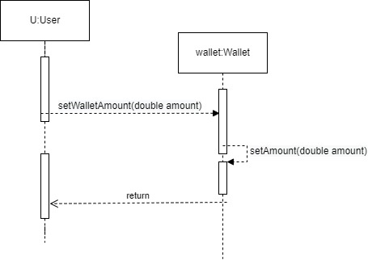

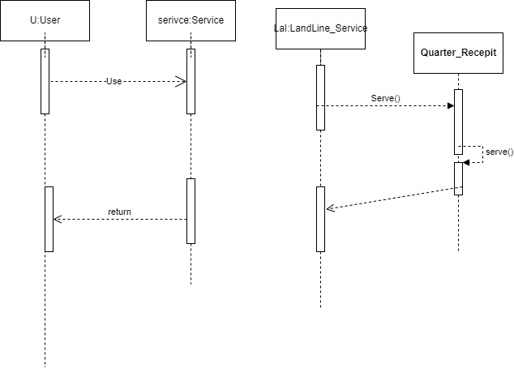

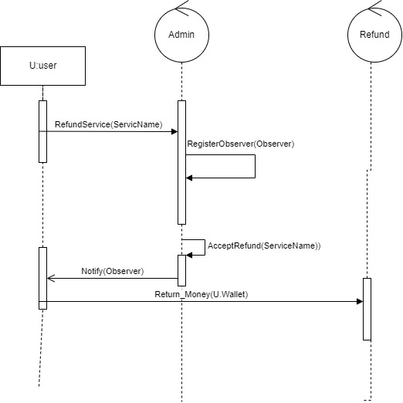

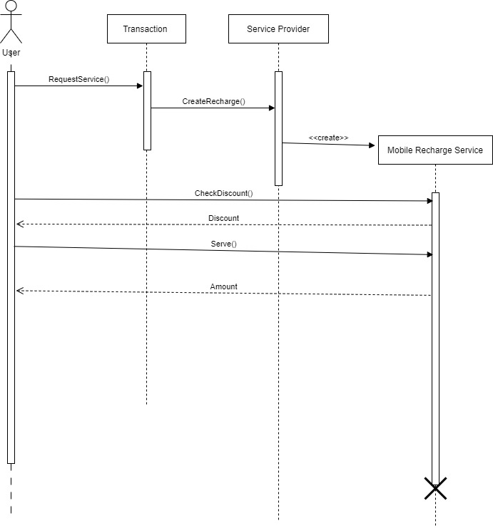

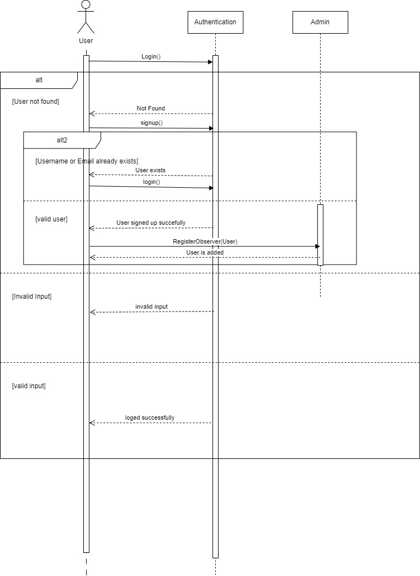

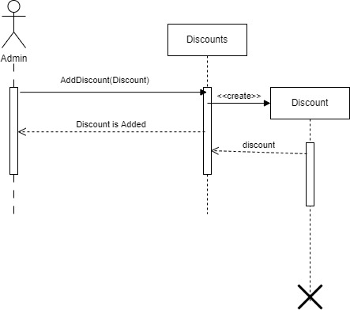

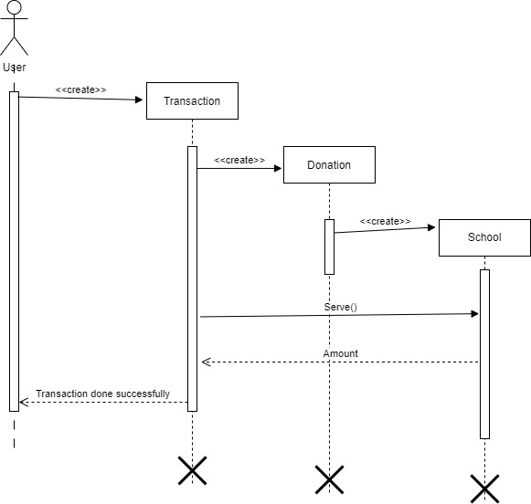

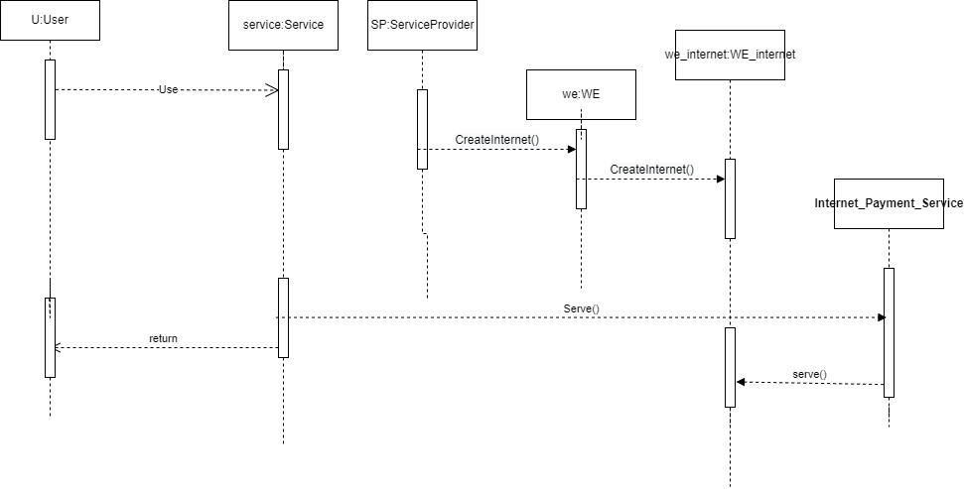

# Requirements Exposure as Web Service API

**Part 1: Exposed Postman Collection**

**Part 2:**

|  |  |  |
| --- | --- | --- |
| Requirement |  | Exposed API |
|  |  |  |
|  |  |  |
|  |  |  |
|  |  |  |

# Github repository link

* **https://github.com/MohammadAyman25-sudo/Software_Project.git**